DATA SCIENCE
`
CYCLE 2 PART 2

1. Create a square matrix with random integer values(use randint()) and use
appropriate functions to find:
i) inverse
ii) rank of matrix
iii) Determinant
iv) transform matrix into 1D array
v) eigen values and vectors

import numpy as np
import numpy as nf
from numpy.linalg import eig
mat = np.random.randint(10, size=(3, 3))
array = nf.random.randint(10, size=(3, 3))
print(mat)

M_inverse = np.linalg.inv(mat)
print("inverse of the array")
print(M_inverse)

rank = np.linalg.matrix_rank(mat)
print("Rank of the given Matrix ")
print(rank)

det= np.linalg.det(mat)
print("determinant of the given Matrix ")
print(det)

arr=mat.flatten()
print("transform matrix to array ")
print(arr)

w,v=eig(array)
print('E-value:', w)
print('E-vector', v)

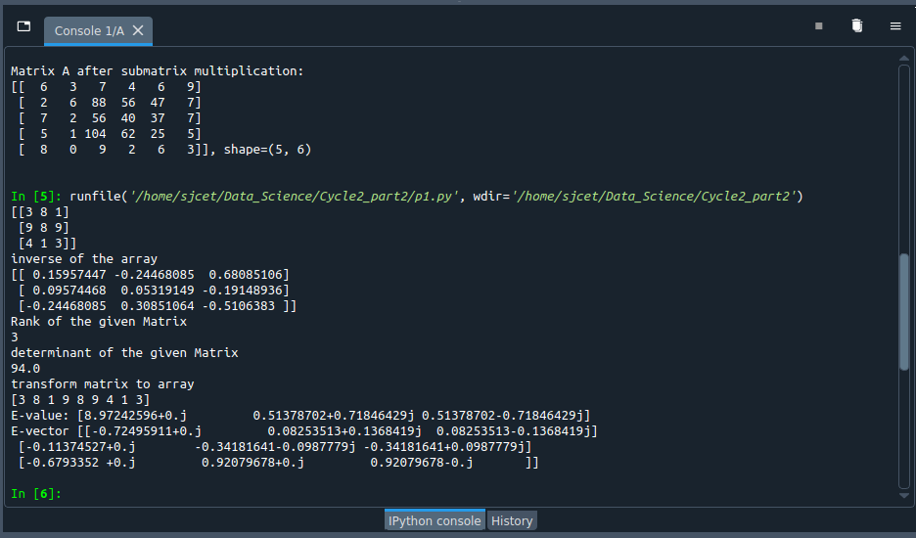

2. Create a matrix X with suitable rows and columns
i) Display the cube of each element of the matrix using different methods
(use multiply(), *, power(),**)
ii) Display identity matrix of the given square matrix.
iii) Display each element of the matrix to different powers.
iv) Create a matrix Y with same dimension as X and perform the operation X 2 +2Y
import numpy as np
x=np.array([[2,3,4],[5,6,7],[8,9,10]])
print(x)
#i) Display the cube of each element of the matrix using different methods
#(use multiply(), *, power(),**)

print(np.power(x,3))
print(np.multiply(x,(x*x)))
print(x*x*x)
print(x**3)
#Display identity matrix of the given square matrix.
b=np.identity(3,dtype=int)
print(b)
#iii) Display each element of the matrix to different powers.
out=np.power(x,x)
print(out)

#iv) Create a matrix Y with same dimension as X and perform the operation X 2 +2Y
y = np.arange(11,20).reshape(3,3)

print("perform the operation X^2 +2Y: \n",np.add((np.power(x,2)),(np.multiply(y,2))))

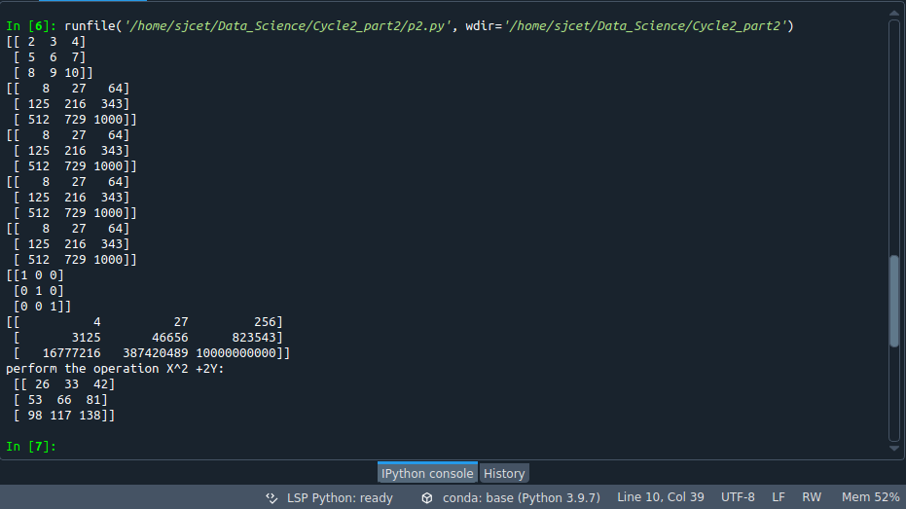

3. Multiply a matrix with a submatrix of another matrix and replace the same in larger
matrix.
import numpy as np

np.random.seed(42)

A = np.random.randint(0, 10, size=(5,6))

B = np.random.randint(0, 10, size=(3,3))

print("Matrix A:\n{}, shape={}\n".format(A, A.shape))

print("Matrix B:\n{}, shape={}\n".format(B, B.shape))

C = A[1:4,2:5] @ B

A[1:4,2:5] = C

print("Matrix A after submatrix multiplication:\n{}, shape={}\n".format(A, A.shape))

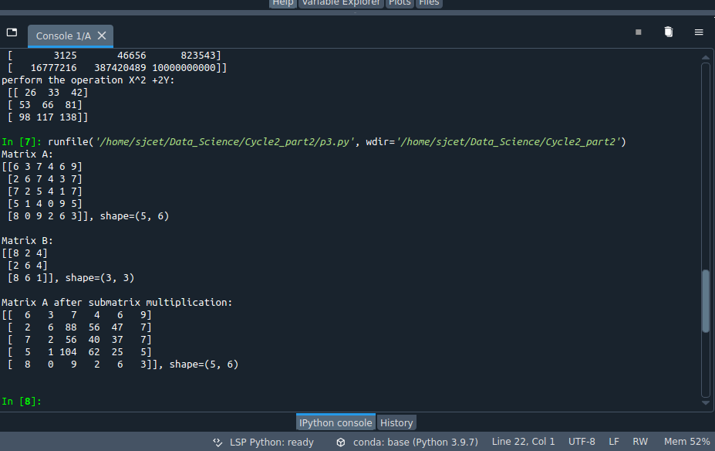

4. Given 3 Matrices A, B and C. Write a program to perform matrix multiplication of
the 3 matrices.
import numpy as np
m1 = np.array([[1,4],[2,5]])
m2 = np.array([[1,4],[2,5]])
m3 = np.dot(m1,m2)
print("multiplication of two matrix")
print(m3)
m4=np.array([[5,6],[1,4]])
m5=np.dot(m3,m4)
print("multiplication of two matrix with third one")
print(m5)
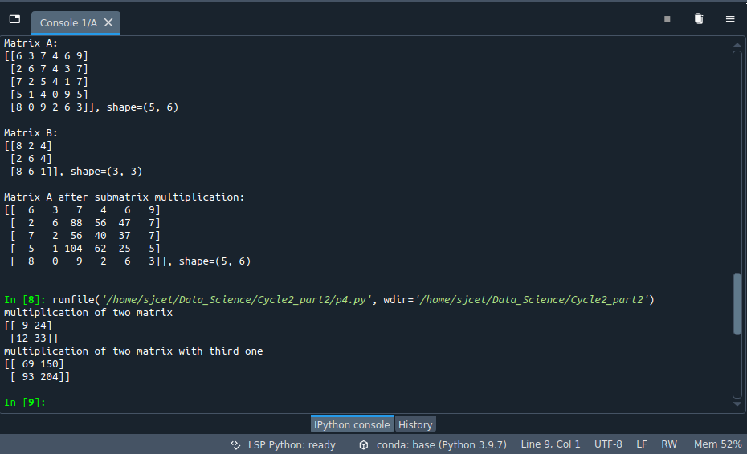

5. Write a program to check whether given matrix is symmetric or Skew Symmetric.
import numpy as np
A = np.array([[6, 1, 1],
[1, -2, 5],
[1, 5, 7]])
print("Original Matrix\n",A)
inv=np.transpose(A)
print ("Transpose matrix\n",inv)
neg=np.negative(A)
comparison = A == inv
comparison1 = inv== neg
equal_arrays = comparison.all()
skew=comparison1.all()
if equal_arrays :
print("Symmetric")
else:
print("not Symmetric")

if skew:
print("Skew Symmetric")
else:
print("Not Skew Symmetric")
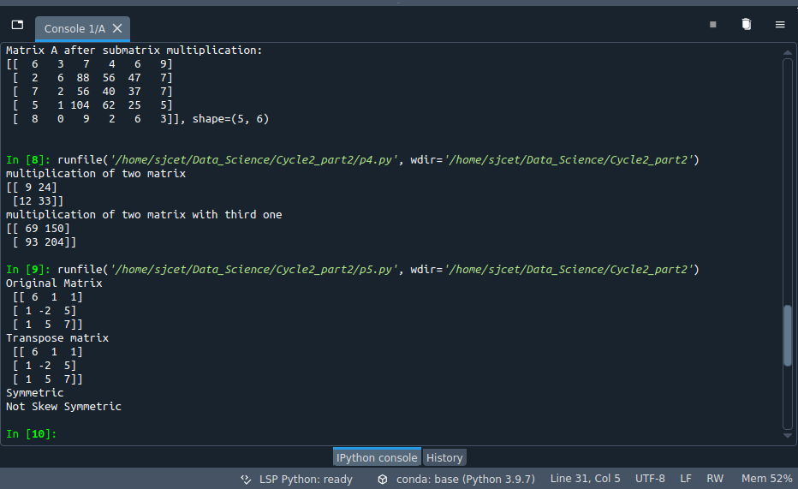

6. Write a program to find out the value of X using solve(), given A and b as above Singular value Decomposition•
import numpy as np
A = np.array([[2, 1, -2],
[3, 0, 1],
[1, 1, -1]])
b=np.array([[3],
[5],
[-2]])
inv=np.linalg.inv(A)
x=np.linalg.solve(inv,b)
print(x)

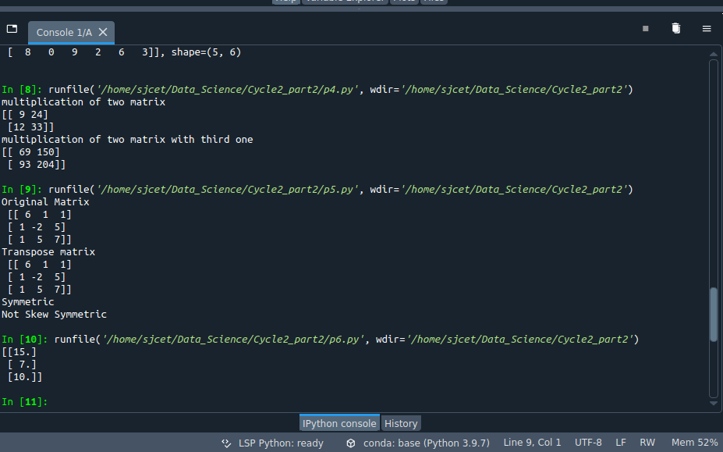

7. Write a program to perform the SVD of a given matrix. Also reconstruct the given matrix from the 3 matrices obtained after performing SVD.

from numpy import array
from scipy.linalg import svd
from numpy import dot
from numpy import diag
# define a matrix
A = array([[1, 2,1], [3, 4,2], [5, 6,4]])
print(A)
# SVD
U, s, VT = svd(A)
print(U)
print(s)
print(VT)
Sigma=diag(s)
B=U.dot(Sigma.dot(VT))
print(B)

